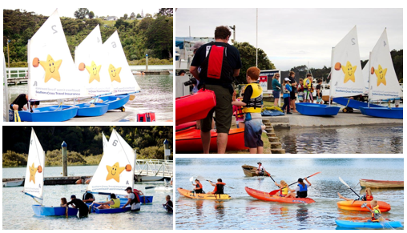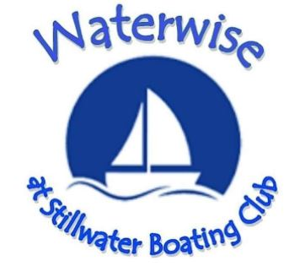

The next season of ‘Waterwise at Stillwater’ is planned to start February 2025.

All children in and outside of the Stillwater region are welcome to enrol in our program.

Waterwise NZ is run here by volunteers who love what it

gives our kids. We would appreciate help and support from

those who would like to become a volunteer or instructor.

Application forms for both participants and helpers can be

downloaded from our website - [*www.swbc.co.nz*](http://www.swbc.co.nz)

**Waterwise Calendar**

**2025**

**1**

**February**

16th Sunday 10.00am

**March**

2nd Sunday 10.00am

16th Sunday 10.00am

**April**

6th Sunday 1.00pm

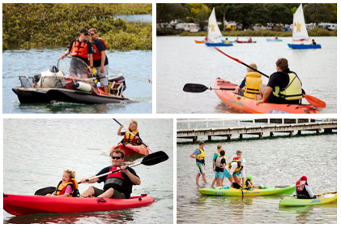

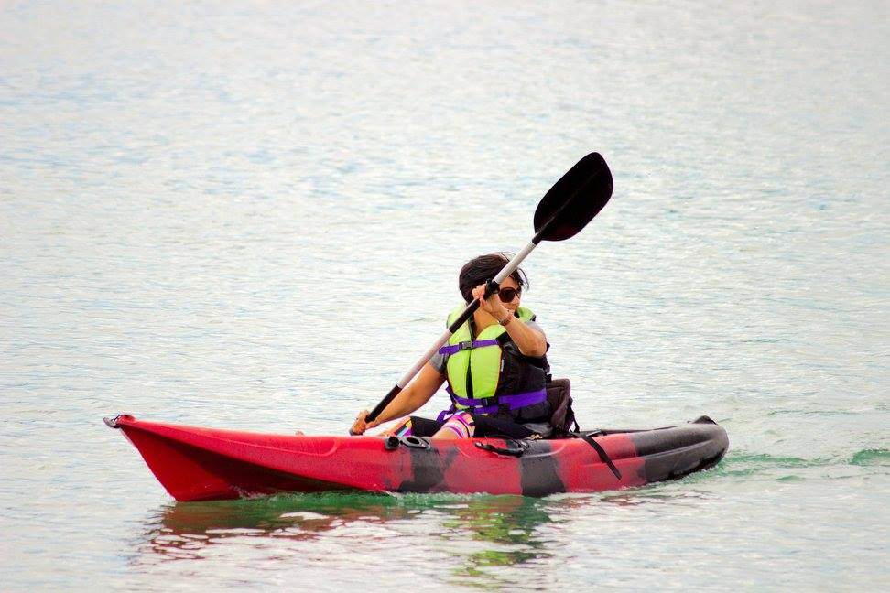

For information and enrolments please email [toerienizelle@gmail.com](mailto:toerienizelle@gmail.com)

**Proudly associated with Waterwise NZ**